Product Review and Rating Management System
Project Title: E-Commerce Order Management Database System

Project Title : E-Commerce Order Management Database System
Student Name : Yakesh J
Register Number : C4S38024
Department : B.Sc Artificial Intelligence
Course : Artificial intelligence (AI)
Academic Year : 2024 – 2027

Step 1: Create Another Database
CREATE DATABASE EcommerceStoreDB;
Step 2: Select the Database
USE EcommerceStoreDB; 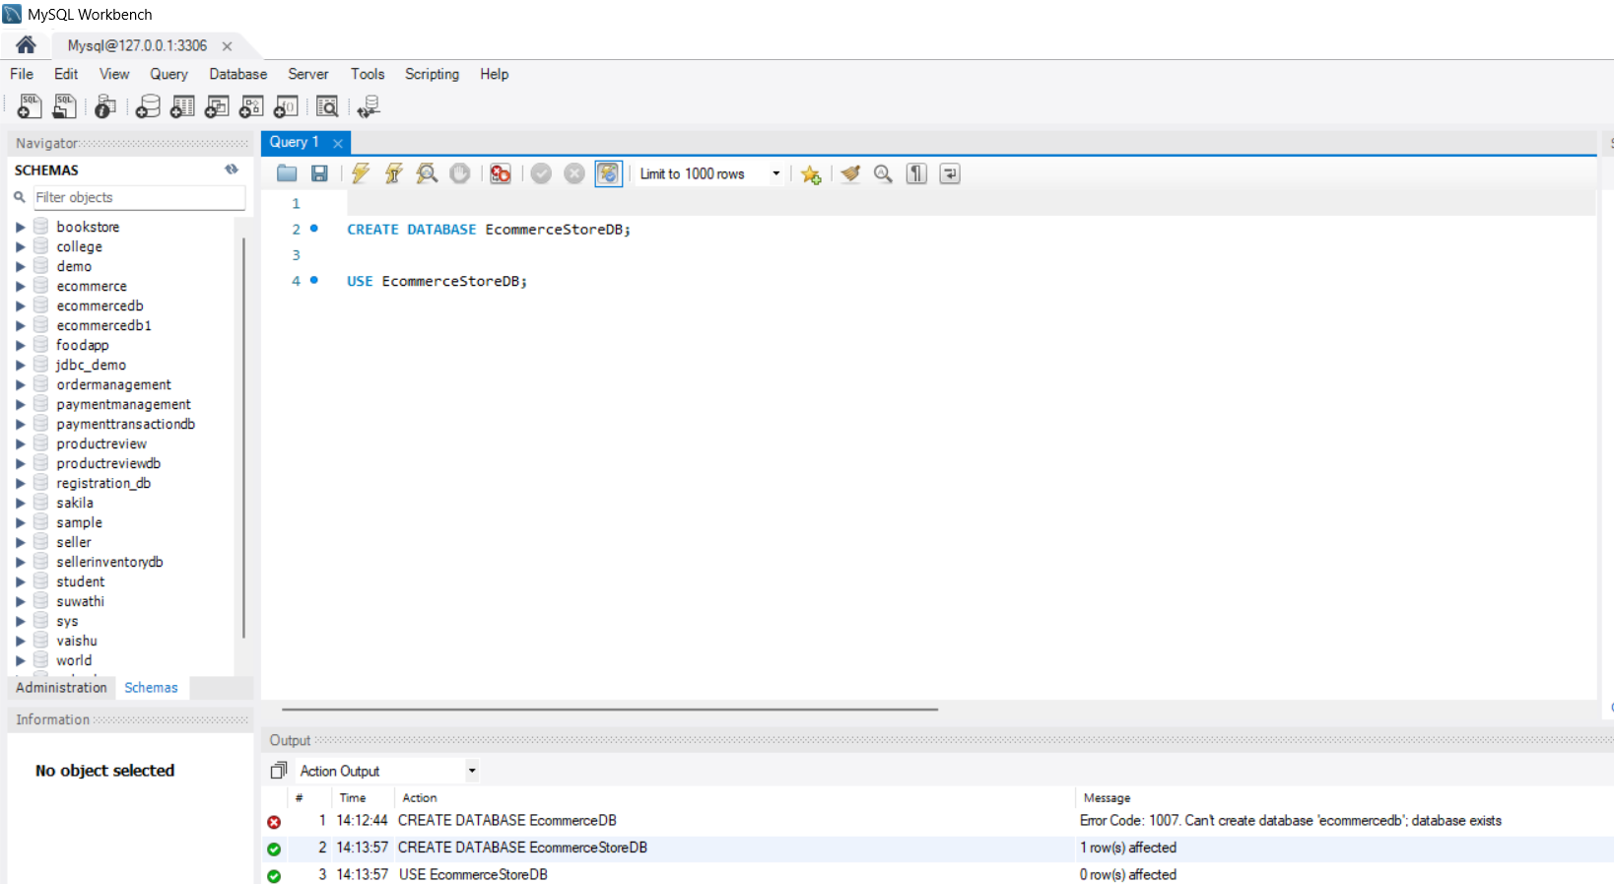
Step 3: Create Product Table
CREATE TABLE Product (
product_id INT PRIMARY KEY AUTO_INCREMENT,
product_name VARCHAR(100),
category VARCHAR(50),
price DECIMAL(10,2),
stock INT
);
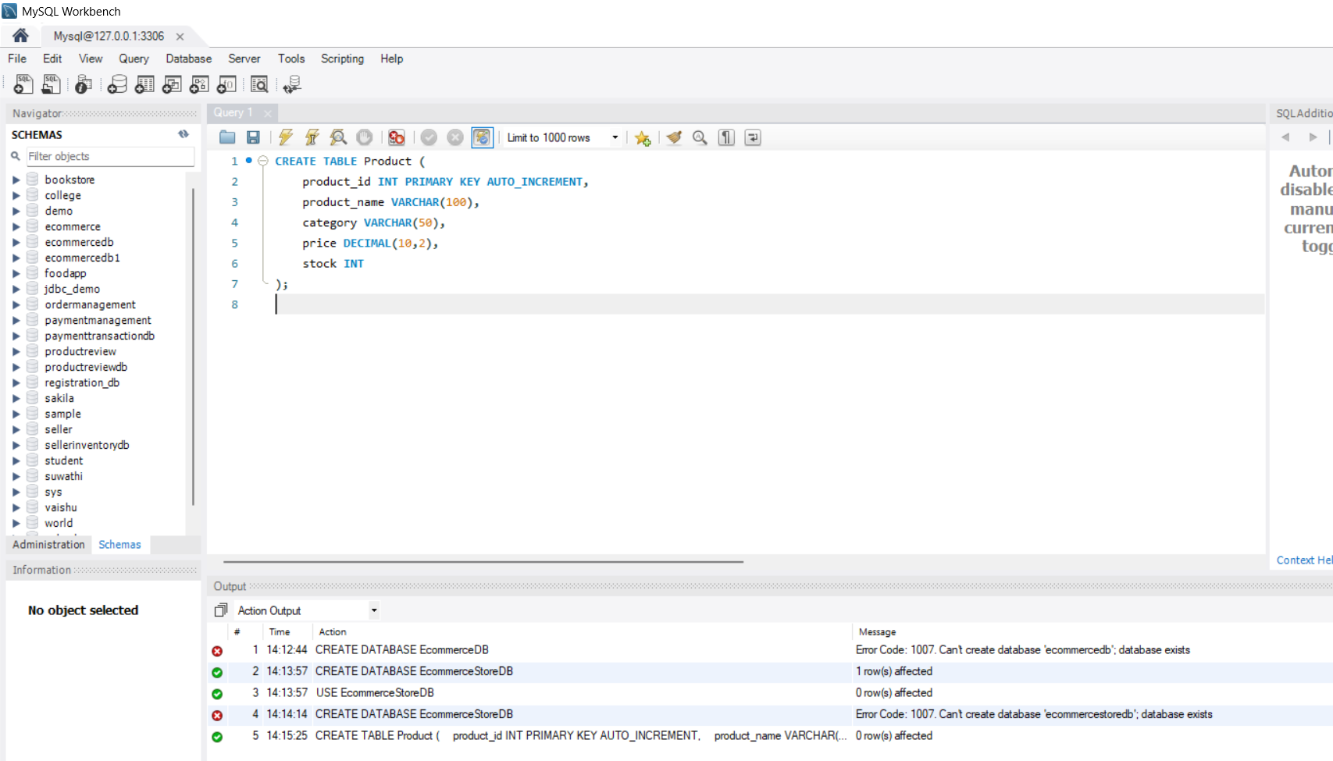
Step 4: Create Customer Table
CREATE TABLE Customer (
customer_id INT PRIMARY KEY AUTO_INCREMENT,
customer_name VARCHAR(100),
email VARCHAR(100),
city VARCHAR(50)
);
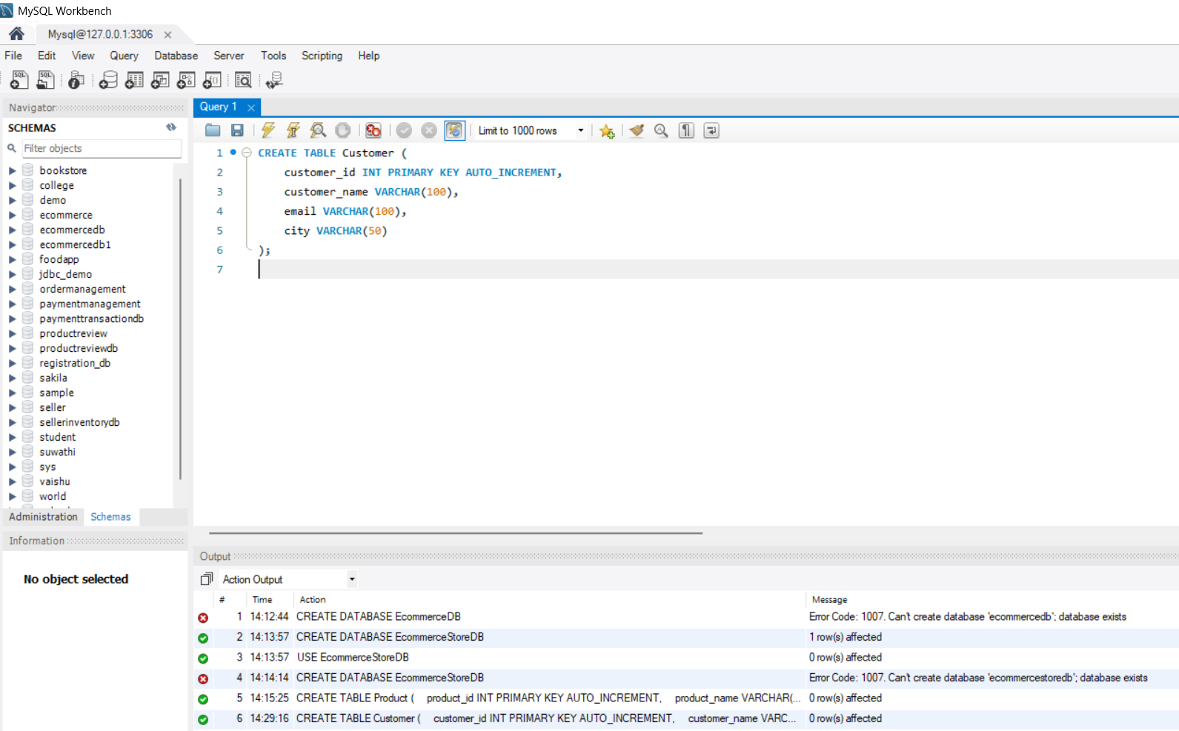
Step 5: Insert Product Data
INSERT INTO Product
(product_name, category, price, stock)
VALUES
('Laptop', 'Electronics', 55000, 10),
('Mobile Phone', 'Electronics', 25000, 20),
('T-Shirt', 'Clothing', 800, 50),
('Shoes', 'Footwear', 2000, 15),
('Headphones', 'Electronics', 3000, 0);
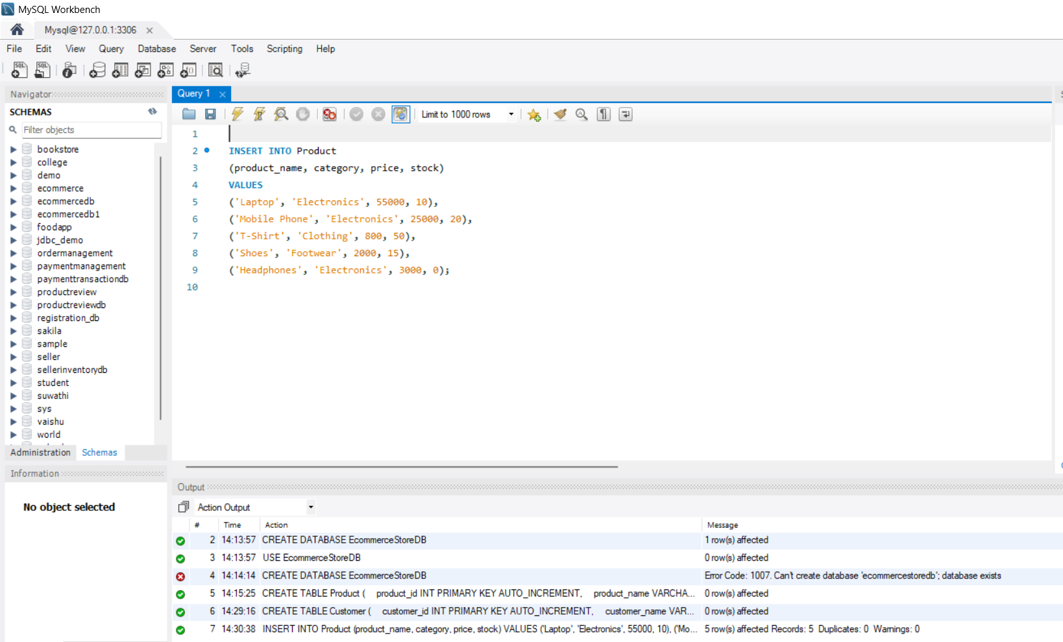
Step 6: Insert Customer Data
INSERT INTO Customer
(customer_name, email, city)
VALUES
('Arun', 'arun@gmail.com', 'Chennai'),
('Kumar', 'kumar@gmail.com', 'Madurai'),
('Priya', 'priya@gmail.com', 'Coimbatore'),
('Anu', 'anu@gmail.com', 'Chennai');
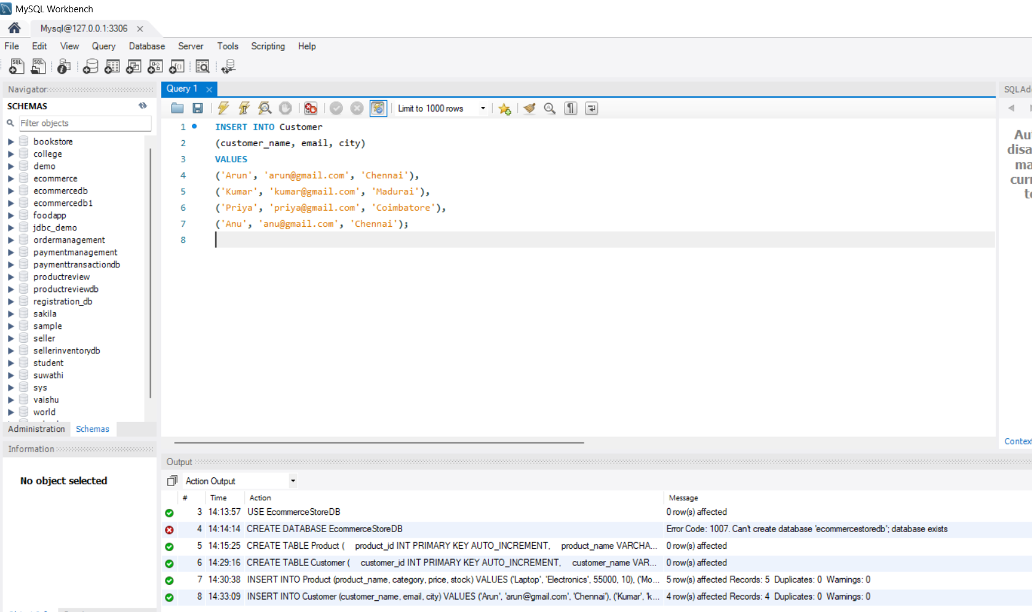
Step 7: SELECT Query
Display all products:
SELECT * FROM Product;
Display specific product details:
SELECT product_name, price
FROM Product;
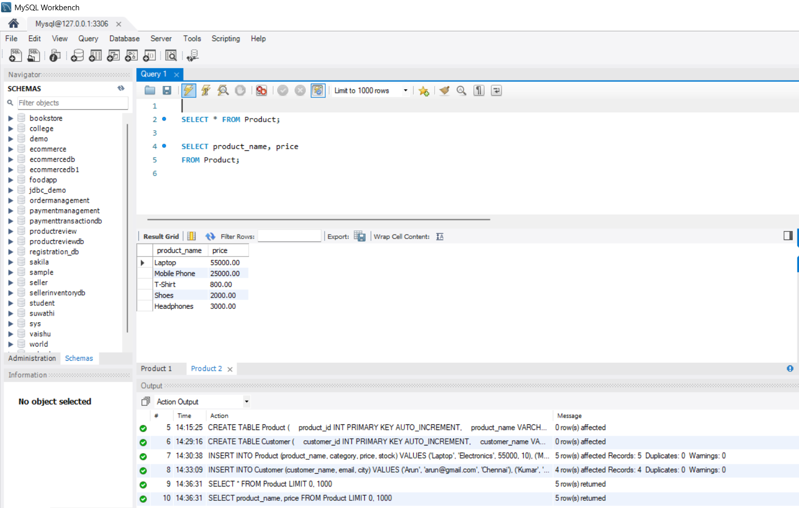
Step 8: WHERE Query
Find products costing more than ₹2,000:
SELECT *
FROM Product
WHERE price > 2000;
Find Electronics products:
SELECT *
FROM Product
WHERE category = 'Electronics'; 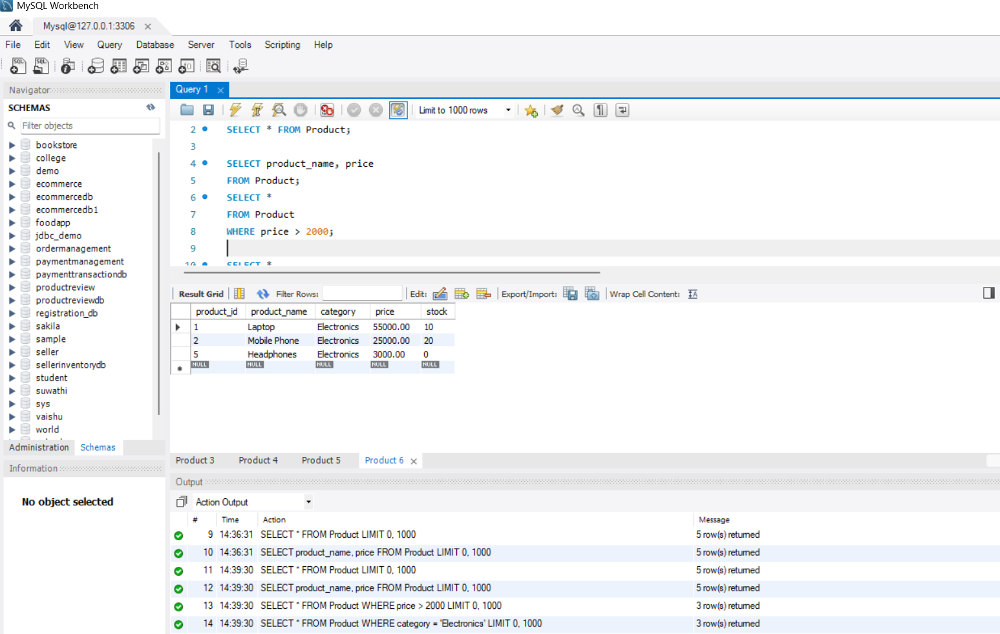
Step 9: ORDER BY Query
Display products from lowest to highest price:
SELECT *
FROM Product
ORDER BY price ASC;
Display products from highest to lowest price:
SELECT *
FROM Product
ORDER BY price DESC;
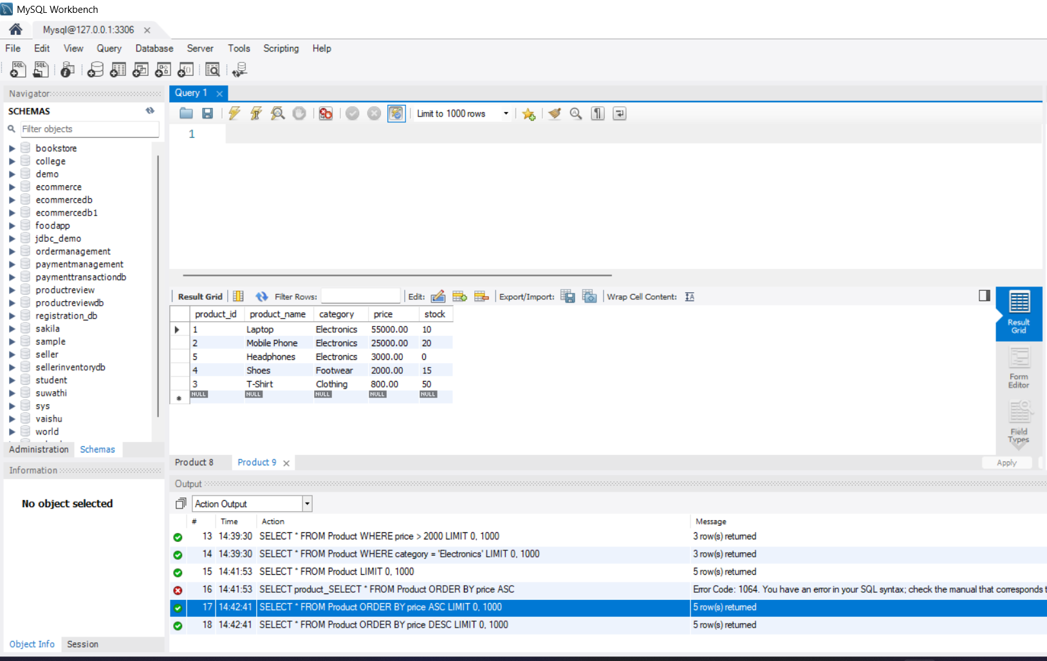
Step 10: DISTINCT Query
Display unique product categories:
SELECT DISTINCT category
FROM Product;
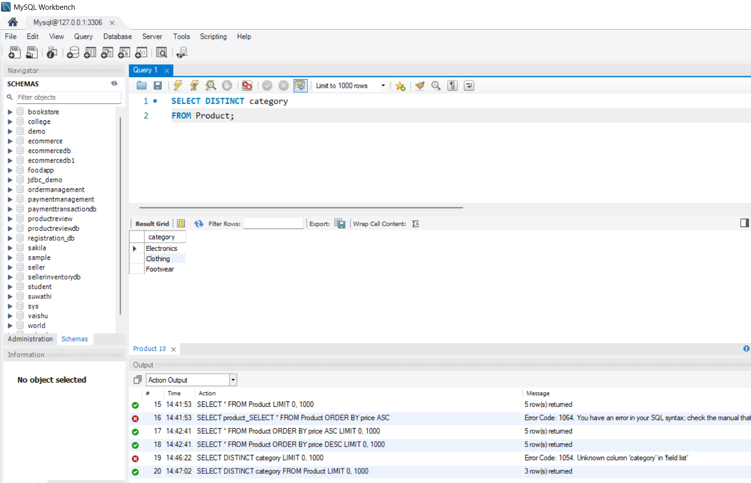
Step 11: Search Products by Price
Products between ₹1,000 and ₹30,000:
SELECT *
FROM Product
WHERE price BETWEEN 1000 AND 30000;
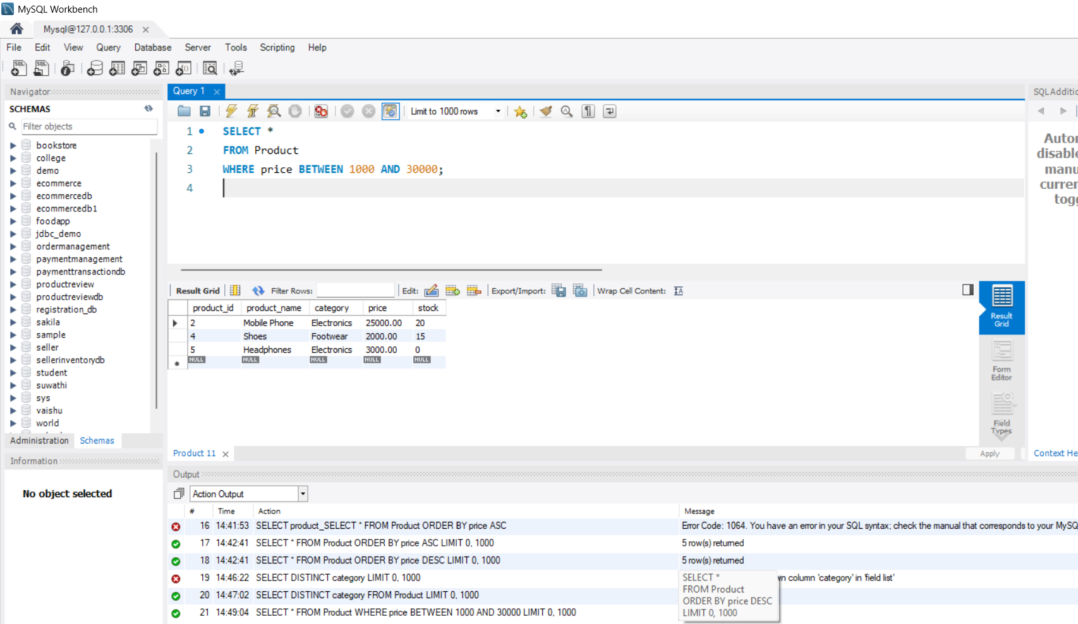
Step 12: Search Products by Category
SELECT *
FROM Product
WHERE category = 'Electronics';
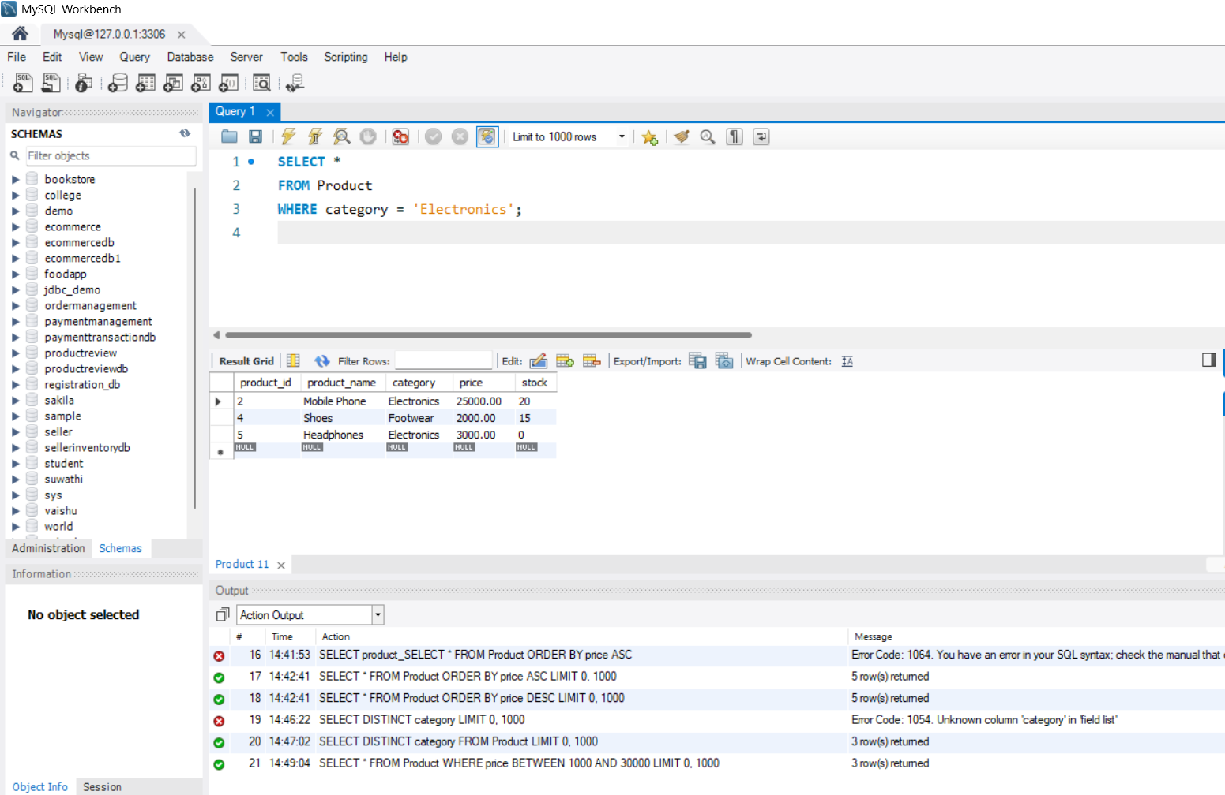
Step 13: Search Available Products
Products that are currently available:
SELECT *
FROM Product
WHERE stock > 0;
Unavailable products:
SELECT *
FROM Product
WHERE stock = 0;
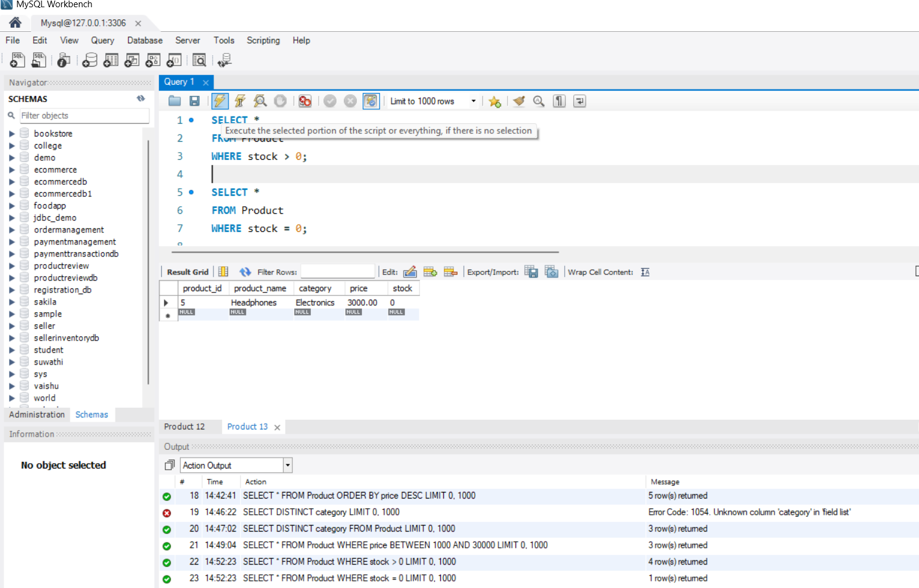
Step 14: Retrieve Customer Information
SELECT *
FROM Customer;
Find customers from Chennai:
SELECT *
FROM Customer
WHERE city = 'Chennai';
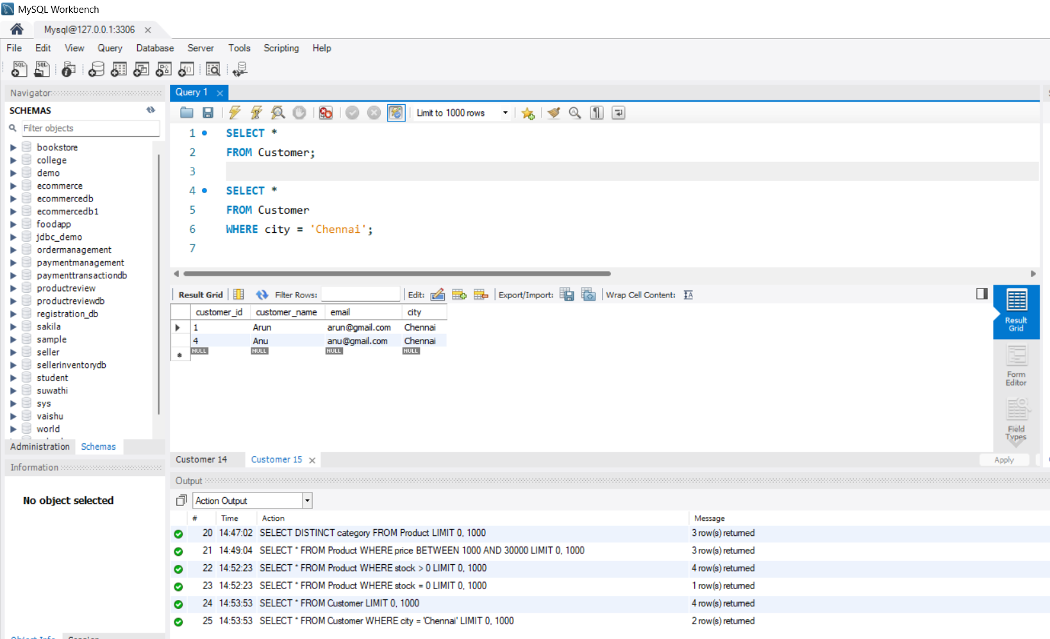
Step 15: Apply Multiple Filtering Conditions
Electronics products costing below ₹30,000:
SELECT *
FROM Product
WHERE category = 'Electronics'
AND price < 30000;
Available products costing below ₹5,000:
SELECT *
FROM Product
WHERE price < 5000
AND stock > 0;
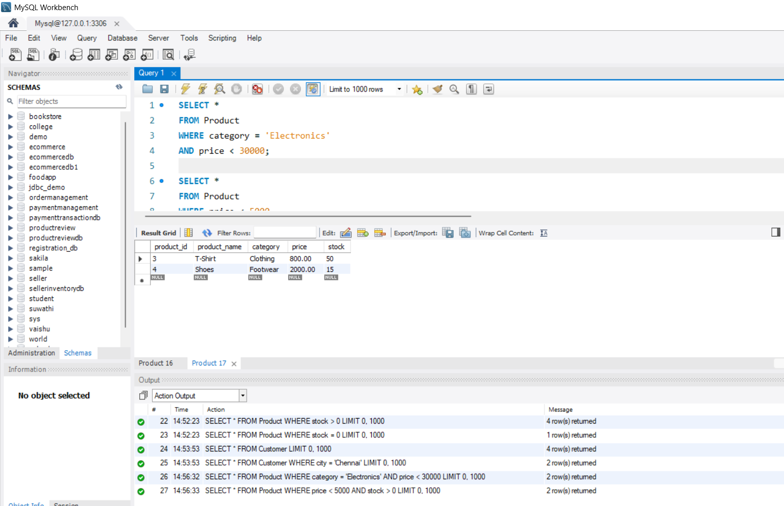
Step 16: Basic Business Report
Product Price Report
SELECT
category,
COUNT(*) AS total_products,
AVG(price) AS average_price,
MAX(price) AS highest_price,
MIN(price) AS lowest_price
FROM Product
GROUP BY category;
Stock Report
SELECT
product_name,
stock
FROM Product
ORDER BY stock DESC;
Category-wise Product Report
SELECT
category,
COUNT(*) AS total_products
FROM Product
GROUP BY category;
Complete Project Flow
